Midpoint Circle Algorithm

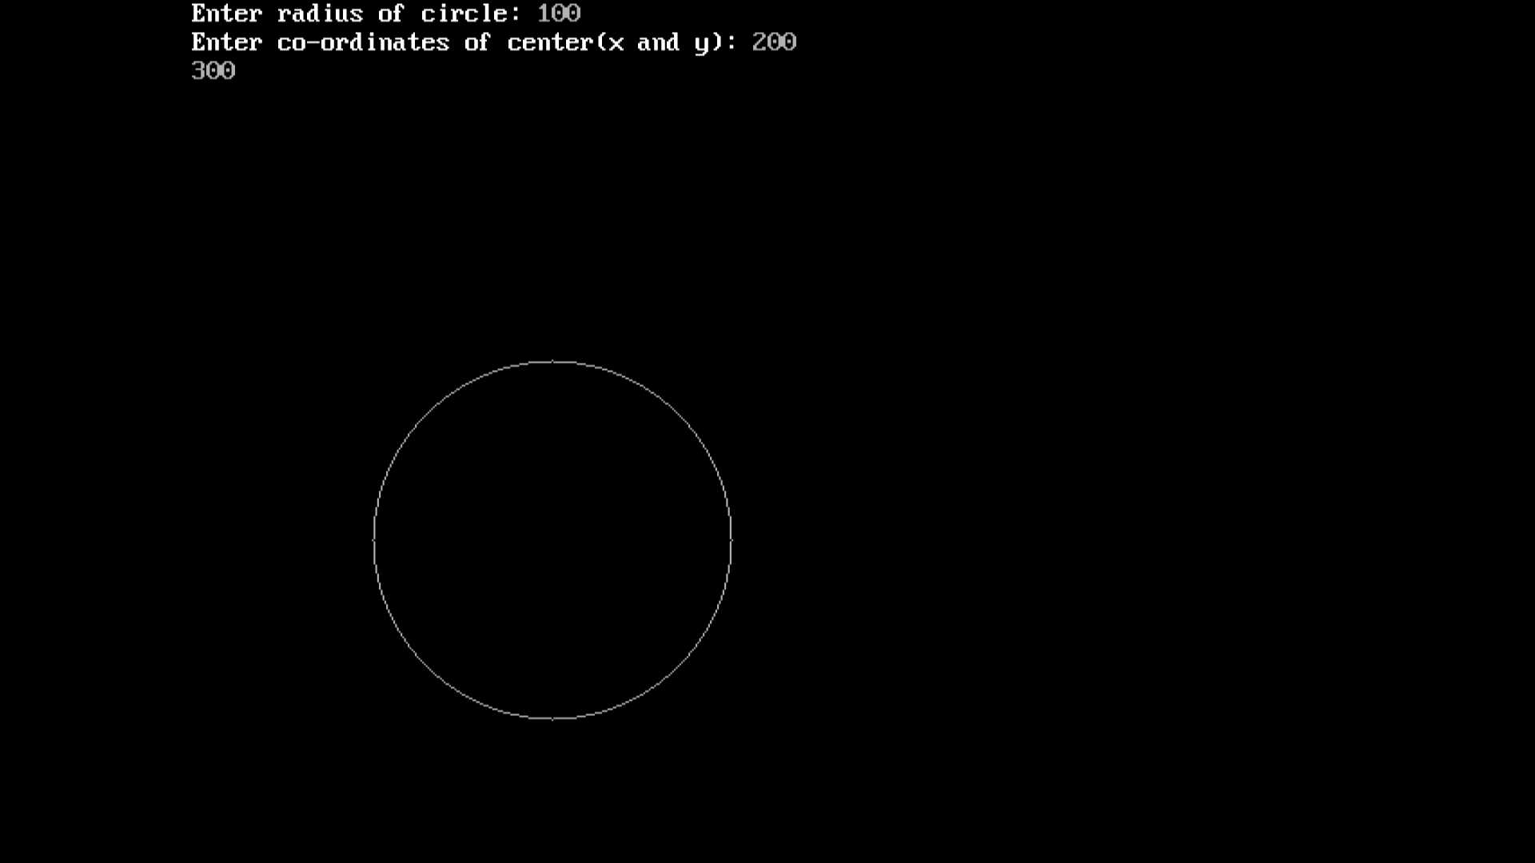

#include<stdio.h>

#include<graphics.h>

void drawcircle(int x0, int y0, int radius)

{

int x = radius;

int y = 0;

int err = 0;

while (x >= y)

{

putpixel(x0 + x, y0 + y, 7);

putpixel(x0 + y, y0 + x, 7);

putpixel(x0 - y, y0 + x, 7);

putpixel(x0 - x, y0 + y, 7);

putpixel(x0 - x, y0 - y, 7);

putpixel(x0 - y, y0 - x, 7);

putpixel(x0 + y, y0 - x, 7);

putpixel(x0 + x, y0 - y, 7);

if (err <= 0)

{

y += 1;

err += 2*y + 1;

}

if (err > 0)

{

x -= 1;

err -= 2*x + 1;

} }

}

void main()

{

int gdriver=DETECT, gmode, error, x, y, r;

initgraph(&gdriver, &gmode, "c:\\turboc3\\bgi");

printf("Enter radius of circle: ");

scanf("%d", &r);

printf("Enter co-ordinates of center(x and y): ");

scanf("%d%d", &x, &y);

drawcircle(x, y, r);

getch();

}

Algorithm:

**Step1:** Put x =0, y =r in equation 2  
            We have p=1-r

**Step2:** Repeat steps while x ≤ y  
            Plot (x, y)  
            If (p<0)  
Then set p = p + 2x + 3  
Else  
            p = p + 2(x-y)+5  
            y =y - 1 (end if)  
            x =x+1 (end loop)